Step 1: Navigate to www.amcp.org and click “Login/Join”
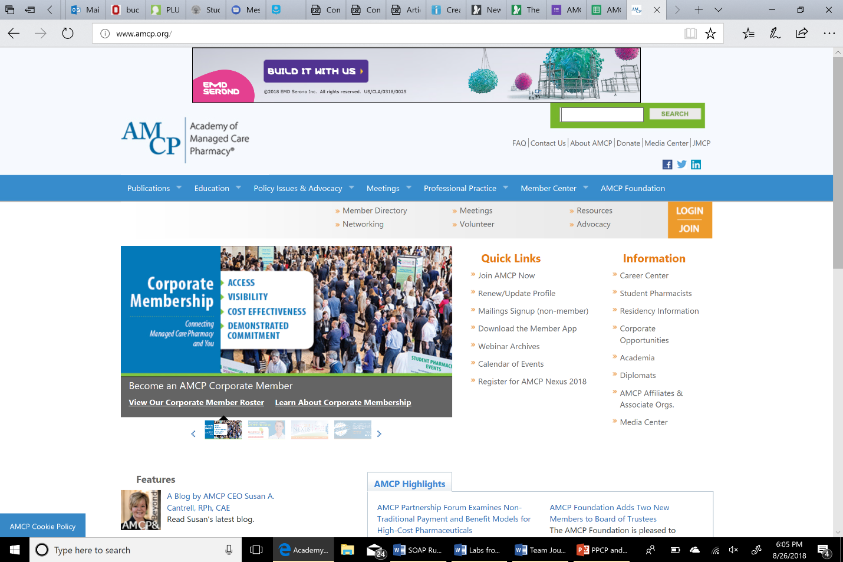

Step 2: Click “Create a Profile”
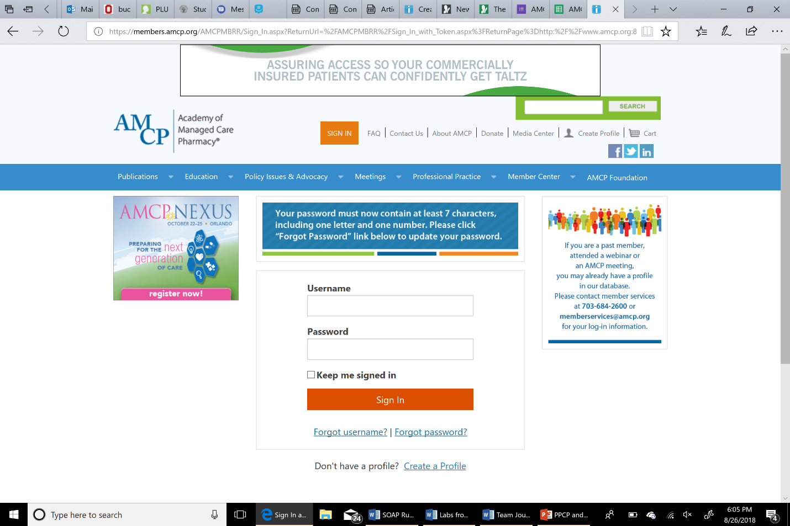

Step 3: Fill out all required areas
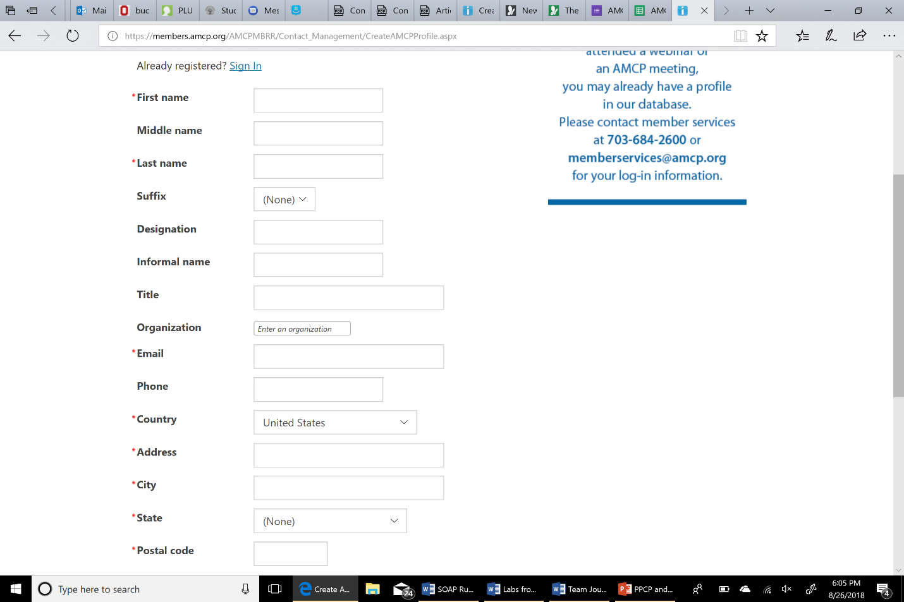

Step 4: Click “Join AMCP Today”
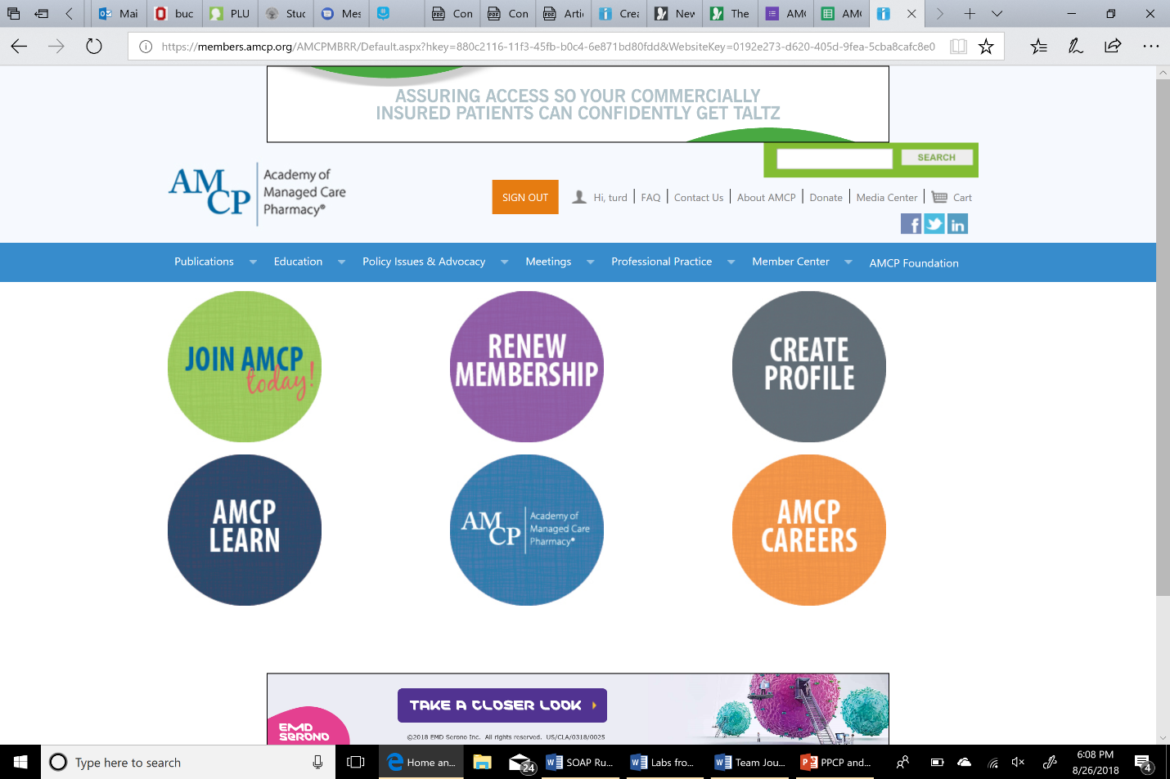

Step 5: Confirm Listed information is correct
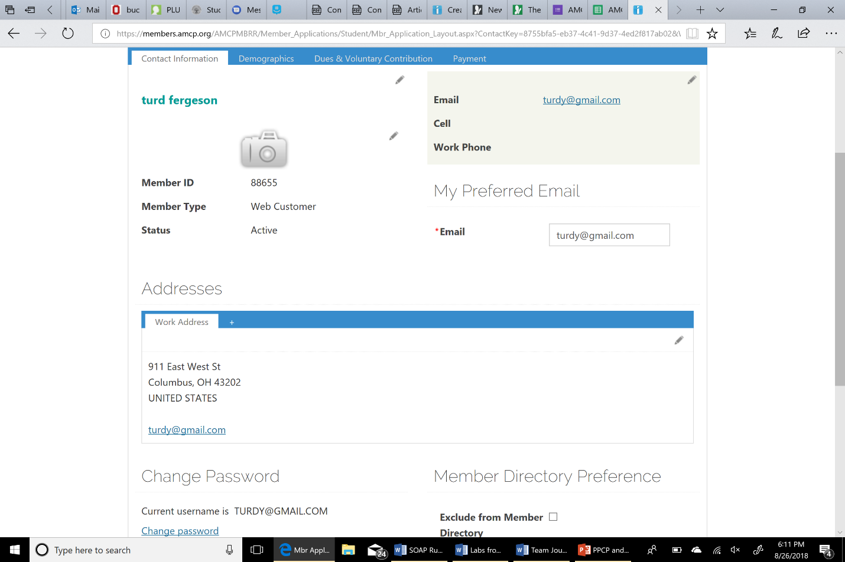

Step 6: Scroll down, click “next”
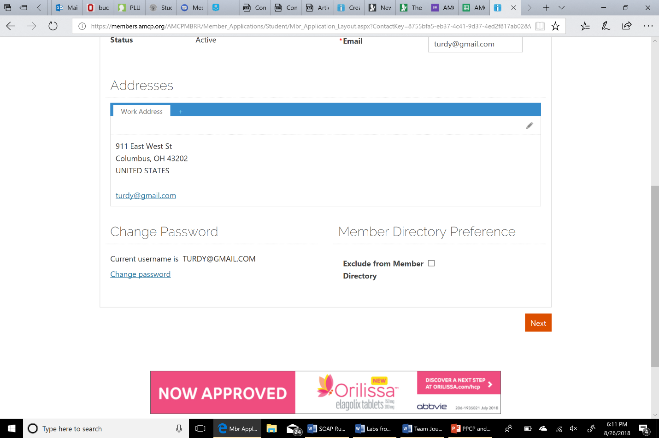

Step 7: List “the Ohio State University” and your applicable graduation year
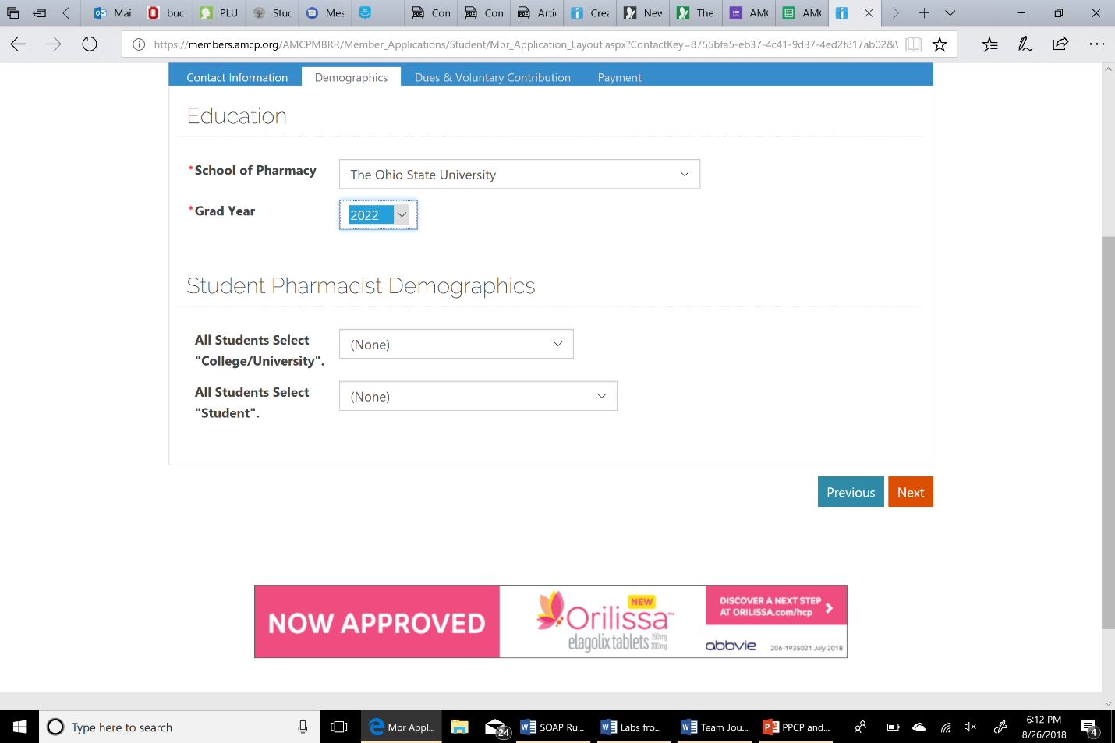

Step 8: Confirm payment (Only $45 on this payment is required)
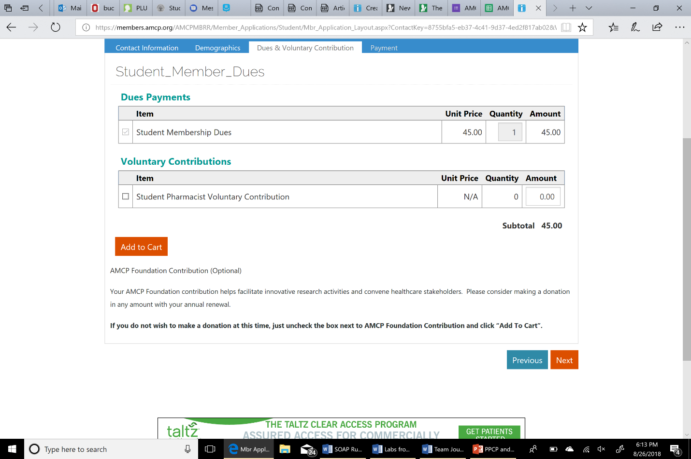

Step 9: Your National Profile and Payment is complete!
